Q2.

Creating jobs and using **top** command to list all top process

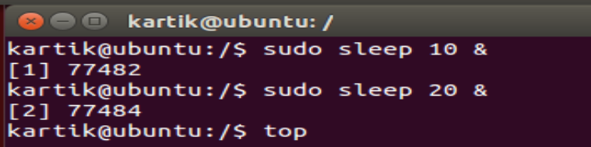

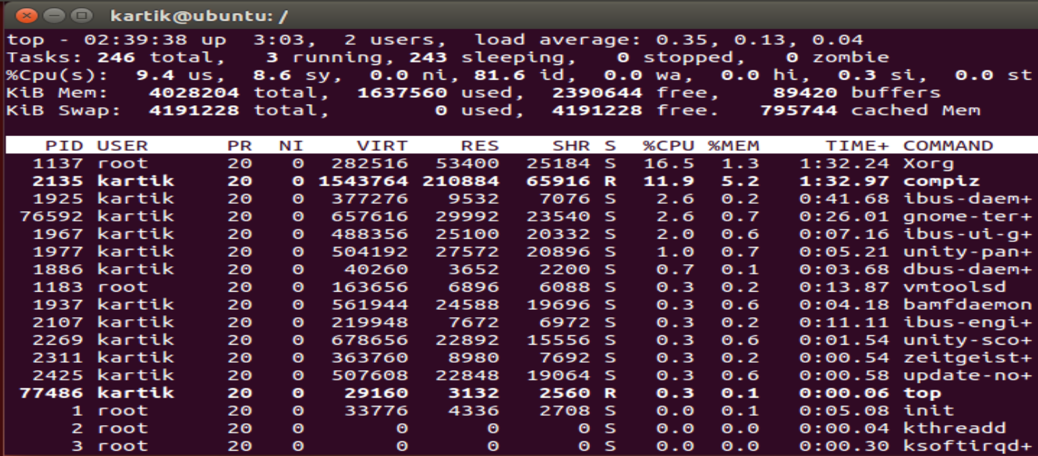

Running a job in vim and finding the pid

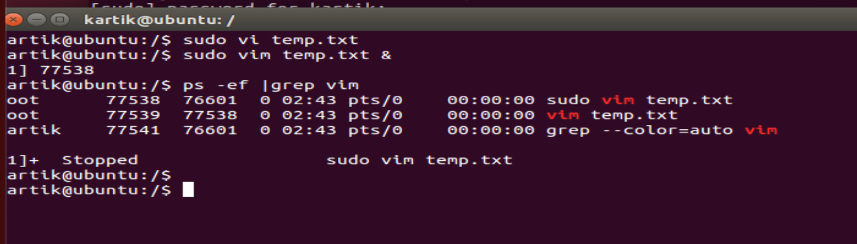

Pid = 77538

Opening a new terminal and checking current priority

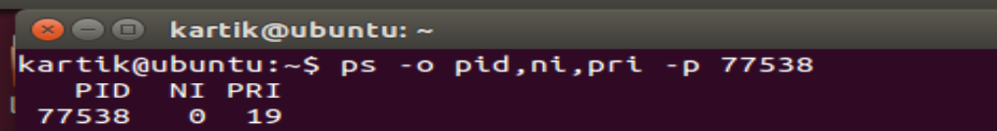

Change the priority to -10



Killing the job

